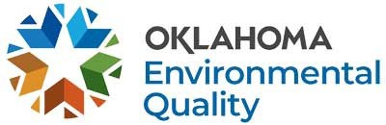

**STATE ENVIRONMENTAL LABORATORY SERVICES DIVISION FIELD PROGRAM LABORATORY ACCREDITATION FEES**

**July 2025 – June 2026**

**Oklahoma Administrative Code 252:302**

Adjusted to correspond with Consumer Price Index of 1.029

**\*The annual assessment fee will be invoiced along with the annual renewal application fee.**

Payment Type Notes:

•

Credit or debit card transactions will be responsible for the additional charges:

* Merchant fee of 2.25% of the amount paid.
* Portal fee of $2.00 per transaction.

Electronic check/ACH transactions will incur a merchant fee of $1.00 per transaction.

•

All payment information should be sent directly to [ARHelpDesk@deq.ok.gov](mailto:ARHelpDesk@deq.ok.gov) for processing.

All questions regarding transaction fees or payment options should be directed to [ARHelpDesk@deq.ok.gov](mailto:ARHelpDesk@deq.ok.gov) or (405) 702-1130.

**Initial Application Fee**: $488.00

**Interim Application Fee:** $279.00

**Renewal Application Fee:** $488.00

**Amendment Fee**: $98.00

**Assessment Fee – Initial/Interim:** $1,071.00

**Assessment Fee – Annual*:** $536.00