Community Based Environmental Protection Projects
Oklahoma Department of Environmental Quality
Request to Enter Contract for Reimbursement
Wasted Food Management Grant Application FY25

The Oklahoma Department of Environmental Quality (DEQ) has the jurisdictional area of environmental responsibility over the prevention, control and abatement of pollution caused by solid waste which presents a threat to human health or the environment, under provisions of 27A O.S. § 1-3-101 and 27A O.S. § 2-10-202; and
The Executive Director of DEQ is authorized under the provisions of 27A O.S. §§ 2-3-201 and 2-3-202 to enter into contracts for the purpose of carrying out any of the purposes, objectives or provisions of the Environmental Quality Code, Title 27A of the Oklahoma Statutes, for which DEQ has jurisdiction.
DEQ is authorized under the provisions of 27A O.S. § 2-10-802(C) to expend funds and enter into contracts with units of local government and political subdivisions of this State for purposes of administering the Oklahoma Solid Waste Management Act.
DEQ does not reimburse for buildings, vehicles, drones, or laptops.
Grant money is not guaranteed. Funding is limited. DEQ’s ability to fund requests to local governments is entirely dependent on the amount of money available to DEQ to issue grants.
Basic Information:
- Grants are provided on a reimbursement basis.
- Grantees must enter into a formal Agreement with DEQ as vendors. No funds are available until a fully executed Agreement and Purchase Order are issued. Funds spent prior to a formal Agreement and Purchase Order are not reimbursable.
- All awarded funding must be spent in the fiscal year granted.
- Agreements expire June 30, 2025.
- Final invoices are due by August 31, 2025. Invoices submitted after August 2025 may not be reimbursed.
- NEW: DEQ will reimburse 80% of equipment costing between $5,000 – $50,000.

Process for Receiving Funds
- Apply
- DEQ reviews application. Discussion between DEQ and applicant may occur at this time. Applicant sends revised Scope of Work and Budget to DEQ, if necessary.
- DEQ writes formal Agreement and sends through state’s procurement process for approval.
- DEQ sends applicant a formal Agreement to sign and return, electronically.
- DEQ signs, then sends an electronic copy of the fully executed Agreement and Purchase Order to applicant.
- Applicant may now begin to spend funds intended for reimbursement. Funds spent prior to a fully executed Agreement and Purchase Order (between steps 1-5) are not reimbursable.
- Applicant sends invoices and monthly reports to DEQ.
- DEQ Reimburses invoices within 45 days.
For more information and application deadlines, visit the DEQ website at https://www.deq.ok.gov/land-protection-division/waste-management/solid-waste/funding-opportunities-for-community-based-environmental-protection-projects/.

Application Submittal Instructions
Return by e-mail to SWGrants@deq.ok.gov with the subject line,
“[Organization] FY25 [grant type] Grant Application DEQ”
e.g., Oklahoma County FY25 Equipment Grant Application DEQ

Or send a hard copy to:
Oklahoma Department of Environmental Quality
Attn: Libby McCaskill, Land Protection Division
P.O. Box 1677
Oklahoma City, OK 73101-1677
Phone: 405-702-5100
Fax: 405-702-5101

Wasted Food Management Project

These grants are for a wide range of projects to reduce wasted food by diverting it from disposal to higher use. The contractor is required to submit invoices and describe their work each month.

WASTE MANAGEMENT CONCERN

An estimated 40% of food grown, processed, and transported in the U.S. will never be consumed. When food is disposed in a landfill, it rots and becomes a significant source of methane – a potent greenhouse gas with 21 times the global warming potential of carbon dioxide. Food reaches landfills and incinerators more than any other single material in municipal solid waste (MSW).
Wasted food equals wasted water. 40% of school cafeteria food is thrown out. 76% of wasted food is fresh milk, fruits, and vegetables – highly valued food items in food banks.
Advancing Sustainable Materials Management: Facts and Figures Report. (2017, February 10). https://www.epa.gov/smm/advancing-sustainable-materials-management-facts-and-figures-report

GOAL
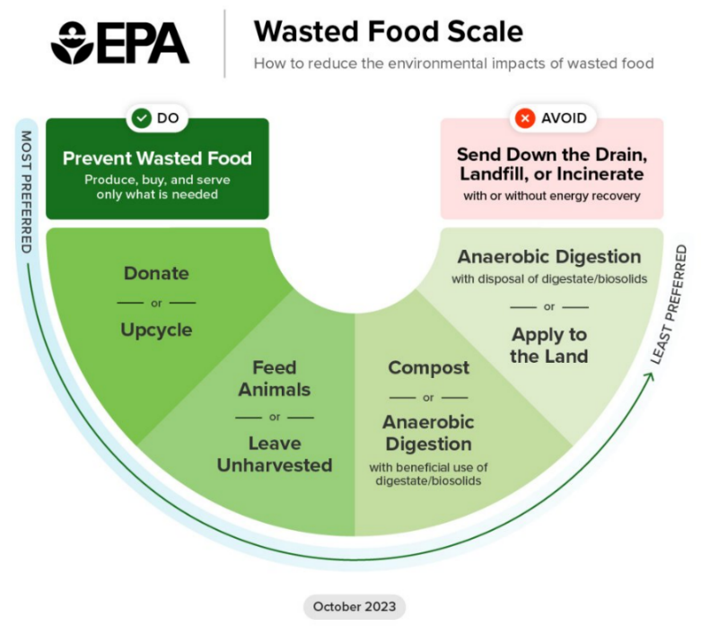
Feed people, not landfills.

OBJECTIVES
- Understand existing food recovery infrastructure in Oklahoma.
- Support new and existing projects that aim to redirect edible food to people experiencing food insecurity, or that divert food from landfills by composting or feeding animals.

OPPORTUNITY
DEQ is soliciting grant applications for projects that propose to reduce wasted food by diverting it from landfill disposal to higher use.

WHO CAN APPLY
Units of government including public school districts, universities, municipalities, counties, and tribes.

EXAMPLE PROJECTS

Examples include, but are not limited to the following:

School/University Food Share Programs
Establish school food share programs, such as “share tables” or “food re-service,” to promote the following:
- Leftovers from school dining are used to feed those who need it within the school community.
- The remainder of edible food is redirected quickly to local food banks for distribution.
- Finally, anything left that cannot be salvaged in another way is composted.

University Sustainability Research Project
Conduct research to define existing food recovery infrastructure for purposes of food recovery and recycling in support of §27A-2-11-103. It is the intent of the Legislature that institutions of higher learning in this state, with the cooperation of the Department of Environmental Quality, conduct studies to facilitate the design and implementation of recycling initiatives.

- Identify public and private organizations that accept and distribute recovered food to people experiencing food insecurity
- Identify public and private generators of food waste that are currently recovering and donating recovered food to people experiencing food insecurity
- Identify sources of recoverable food, e.g., restaurants, grocery and convenience stores, university cafeterias, etc.
- Identify resources for matching generators of recoverable food with recovery organizations and distributors
- Identify all applicable laws, regulations, health codes, and ordinances that relate to food donation
- Create database of resources, e.g., GIS map to share the research outcome
- Develop a program, such as, a mobile app to match recoverable food resources with recovery organizations

Community Food Recovery Startup Expense Assistance
DEQ funding can be used to pay for:
- Bins/baskets to collect the food – size and type varies by school/food pantry partnership and refrigerator space available
- Educational materials such as signs, posters, and social media promotions
- Labels attached to the bins, e.g., stating the contents are for donation
- Refrigerators or coolers, e.g., to hold the food until picked up for delivery to food bank

Wasted Food Management Grant Application FY25

The following information must be provided before a contract for reimbursement will be considered. Scoring will be based on the following categories: environmental improvement, feasibility, collaboration, public outreach, sustainability, scope of work and budget, quality of proposal, and past performance, if applicable. This form has been prepared to be applicable to a wide range of projects and as a result some of the questions may not seem directly applicable to what you propose. Please answer the questions to the best of your ability based on the information you have.

Date:

1. Legal name of organization seeking a reimbursement agreement (must be unit of government, public school district, or university, municipality, county, or tribe)

2. Dollar amount being requested:

3. Contact information for organization:
Name:
Phone Number:
E-mail Address:

4. Signatory Authority for organization with legal authority to sign contract with DEQ:
Name:
Phone Number:
E-mail Address:

5. Addresses
The contract will be sent here for signature (name and e-mail):
Reimbursements will go to this mailing address:

6. Other
How did you hear about DEQ’s Solid Waste Management Grant Program?

7. Project Description. Answer each question in its answer box to the right.

Project Type
Question | Answer
- Describe what type of project you are proposing.
- School Share program
- Community food recovery/distribution
- University research project
- Other?
- What is the source of wasted food to be managed with this project?

- What happens to the wasted food now?

- Who will be served by the program?

- Is this a new project or will it support an existing effort?

- Have you researched all applicable laws, regulations, health codes and ordinances that may apply to this project and concluded your project will be compliant?

Public Outreach
Question | Answer
- Describe the public outreach plan for your community, such as news coverage, radio ads, flyers, posters, social media, and at what frequency. Please list your social media handles, if applicable.

Need
Question | Answer
- What is the total cost of the program?

- Are you partnering with anyone else to implement this program? If so, describe. To make more efficient use of limited dollars DEQ will prioritize applications that propose partnerships and collaboration.

- Have you received a previous grant from the DEQ? If yes, what years, what dollar amount of funding was provided, and how much of that funding did you spend?

Project Longevity
Question | Answer
- How long do you intend for the program to remain in place?

- What metrics will you track monthly to quantify the success of your project?

Scope of Work & Budget
Question | Answer
- Please attach a detailed scope of work including timeline, principal staff or participants, and detailed budget, for the entirety of the project. | More detailed and itemized budgets will be prioritized. Examples of budgeted line items include cost of labor, equipment, supplies, etc.

Additional Information
Question | Answer
- What other information would like to share in support of your project?

