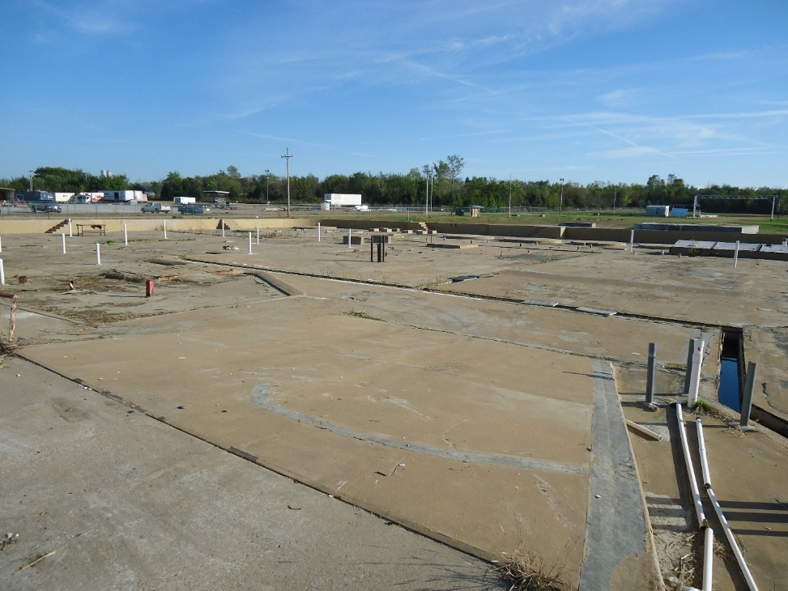
Former solvent recycling plant view towards the southeast

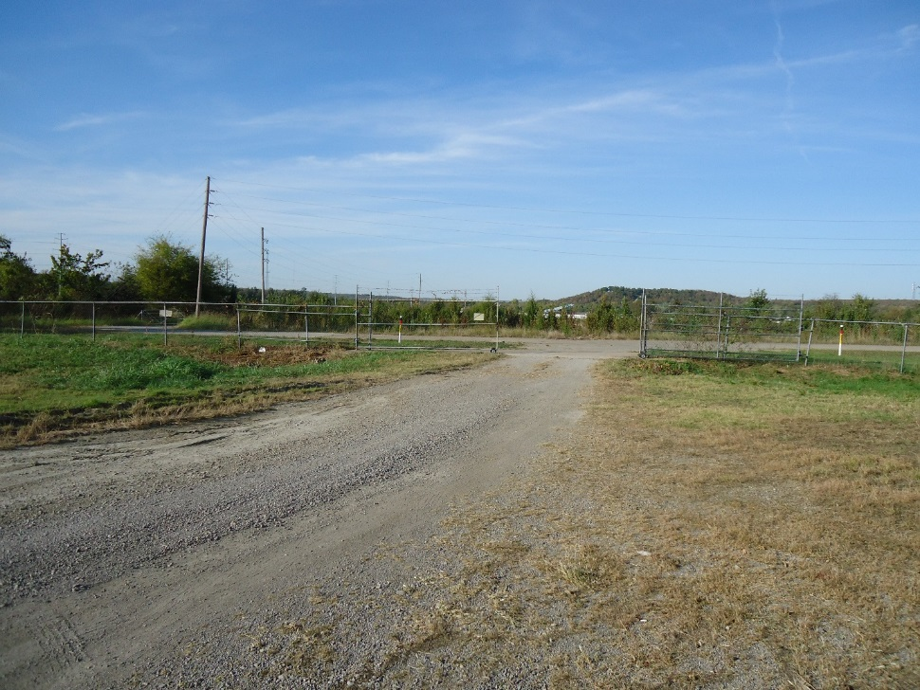
West entry gate to facility from the south facing north

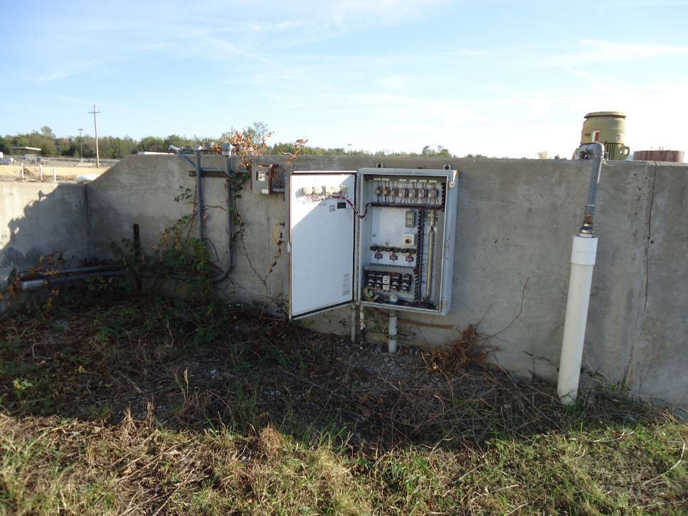
Groundwater collection system control panel

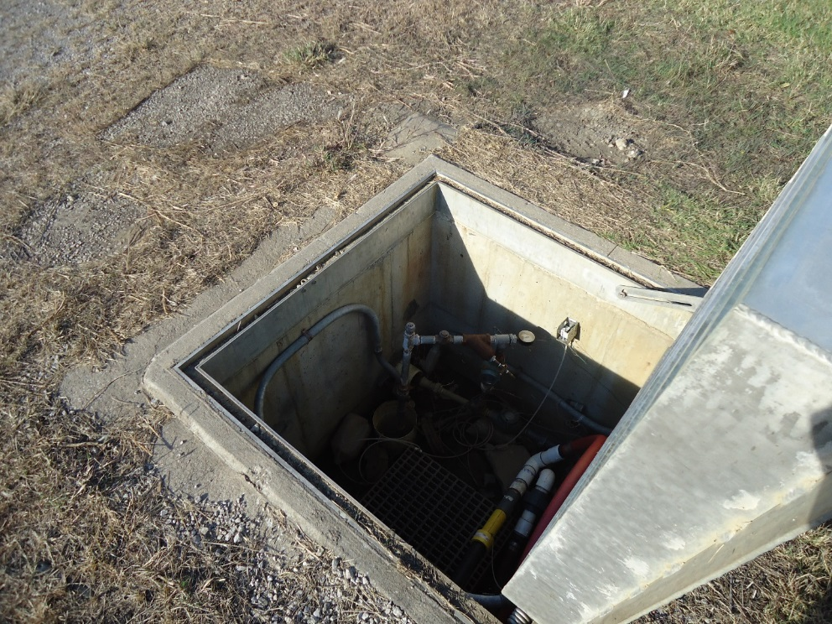
Recovery sump #4
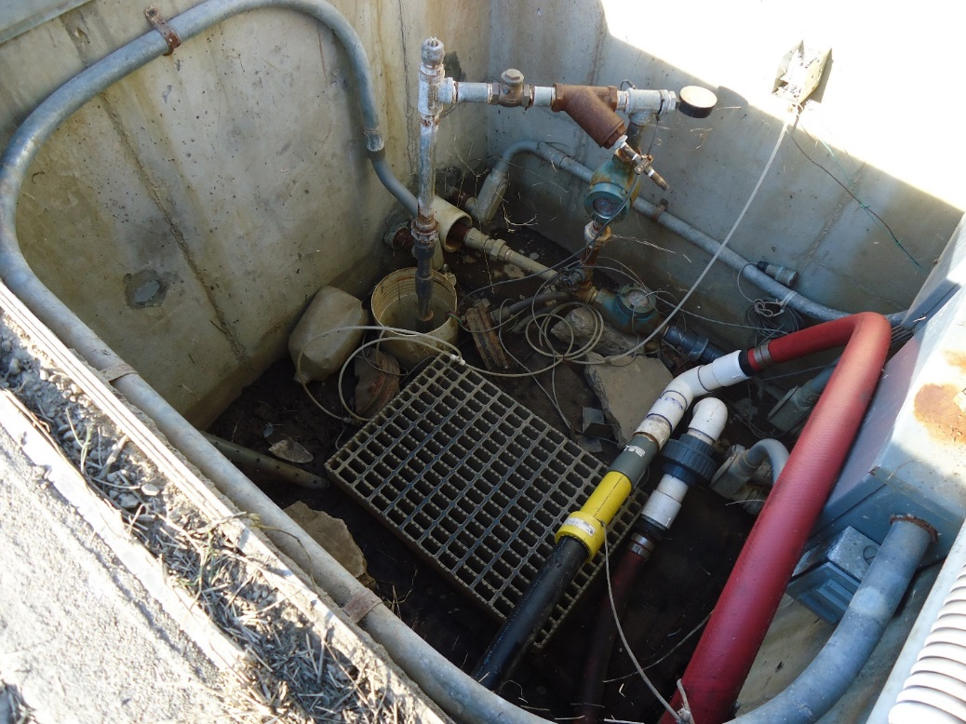
Inside of Recovery Sump #4

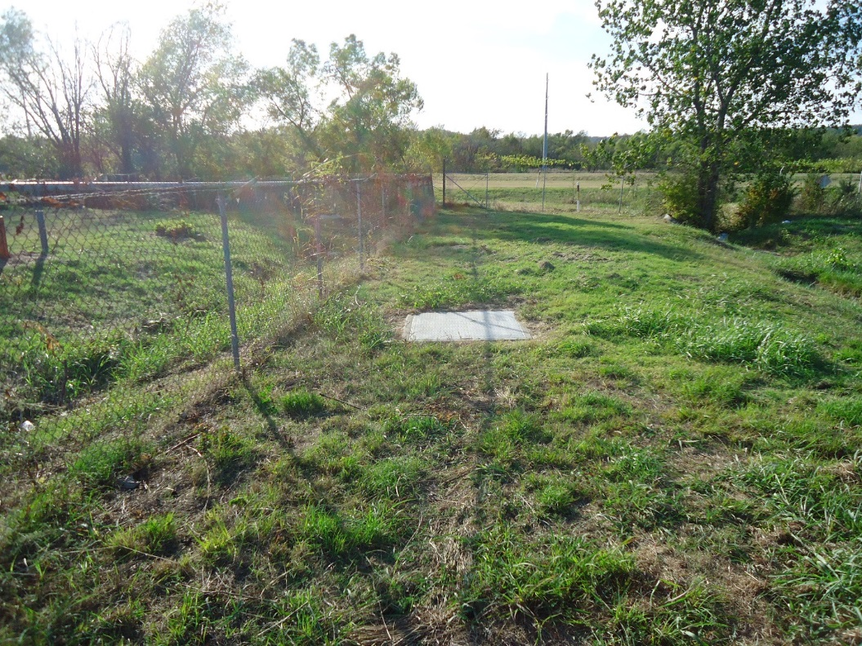
Recovery Sump #2 outside facility north fence (outer collection trench)
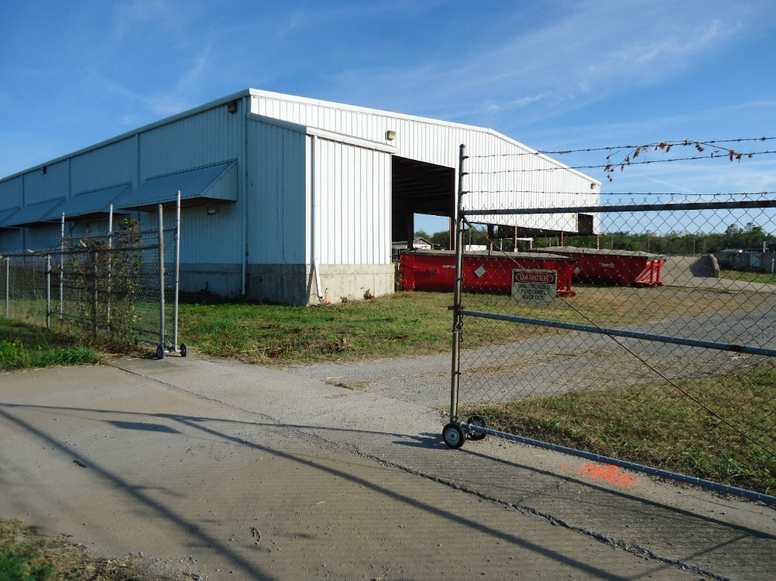
North entry gate facing southeast and North drum storage pad under roof

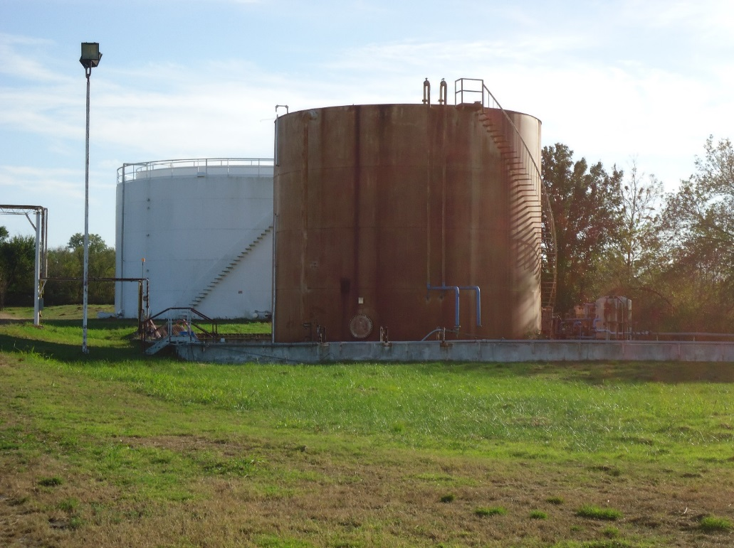
Tank V-68 (foreground) and Tank V-69 (background)
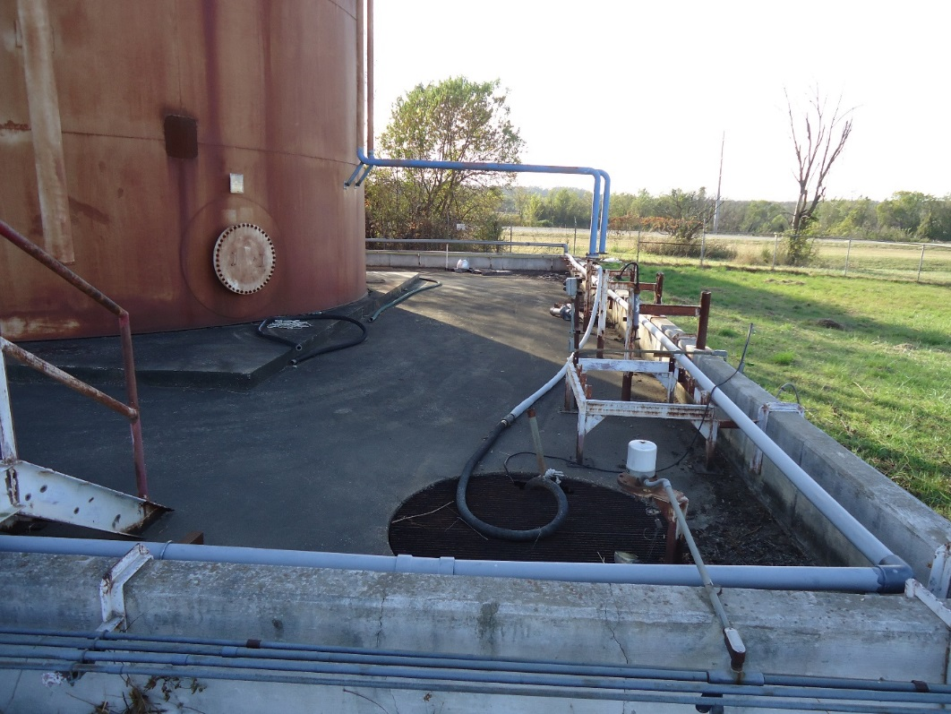
Tank V-68 secondary containment and sump

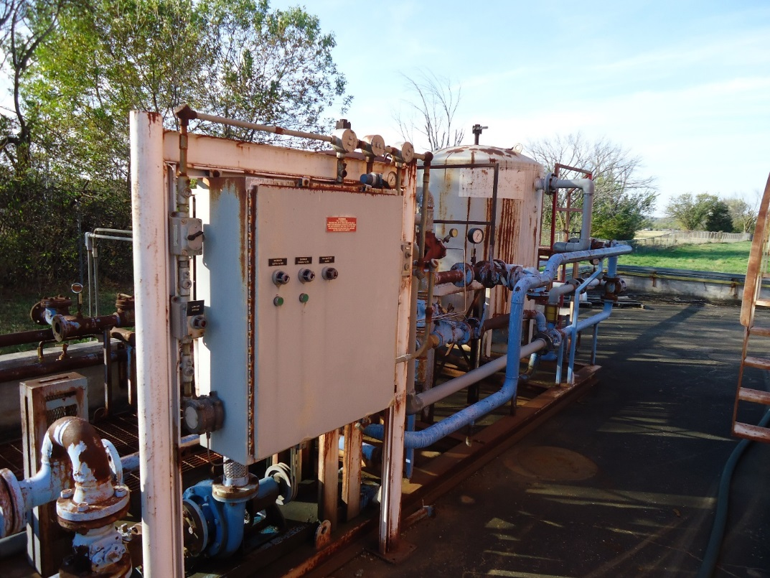
Water treatment system carbon bed
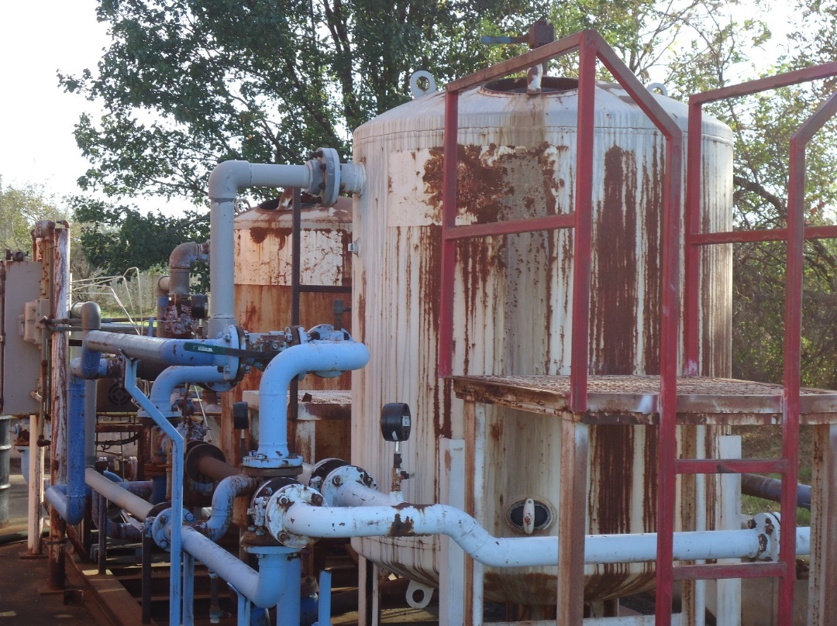
Water treatment carbon bed

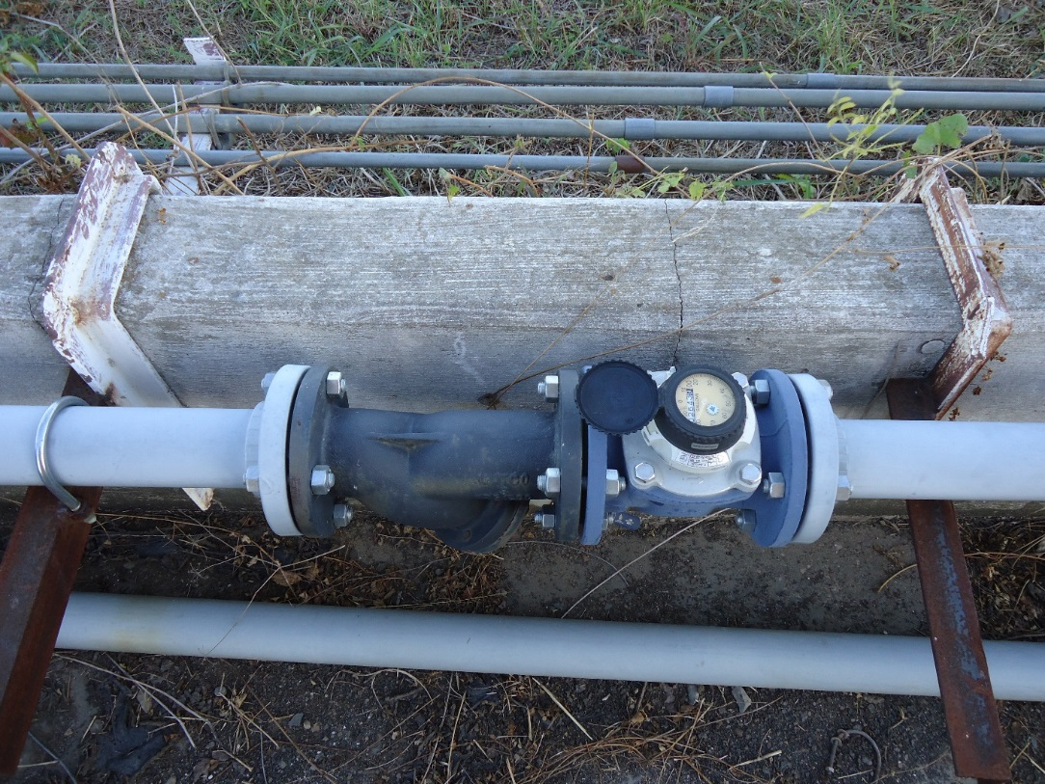
3-inch discharge pipe to POTW with totalizing meter
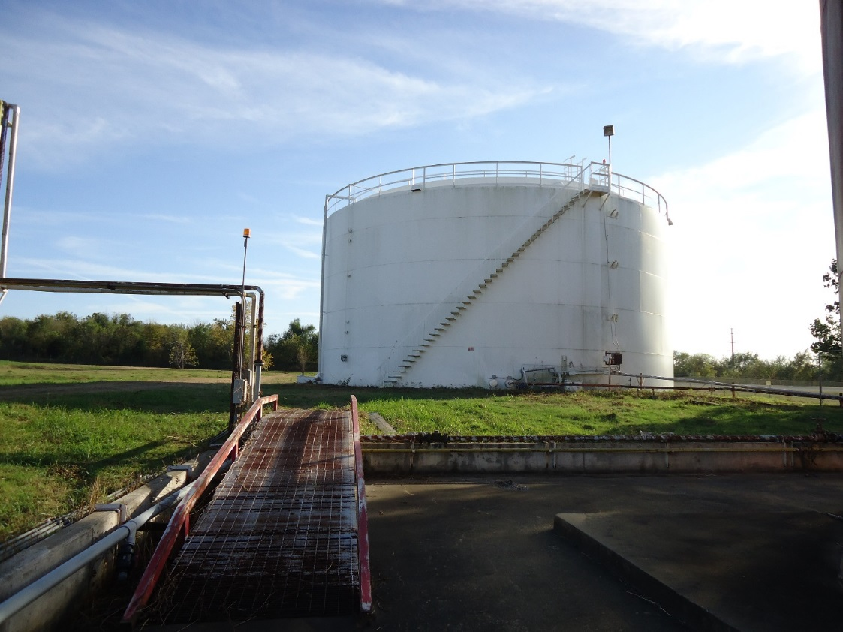
Groundwater collection tank V-69

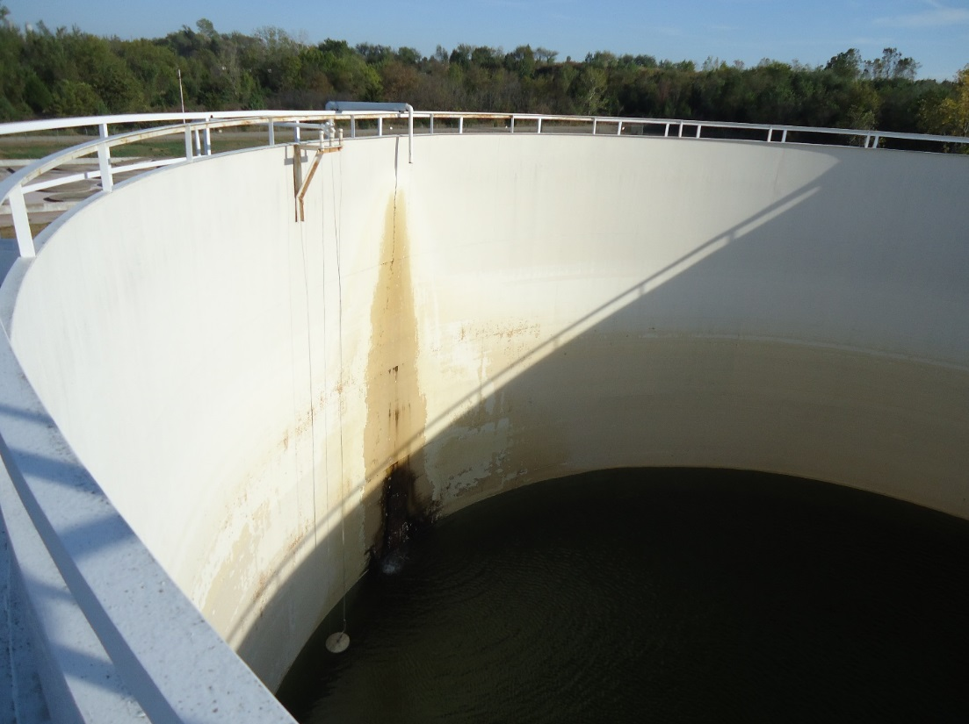
Inside view of groundwater collection pipe into double walled open top tank
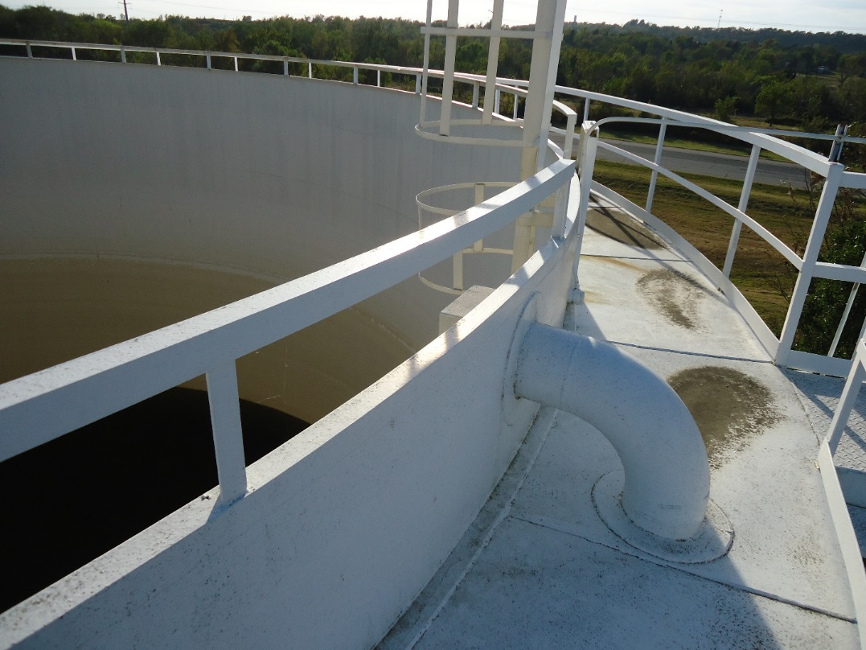
View of annulus walkway between the inner and outer tank (secondary containment)

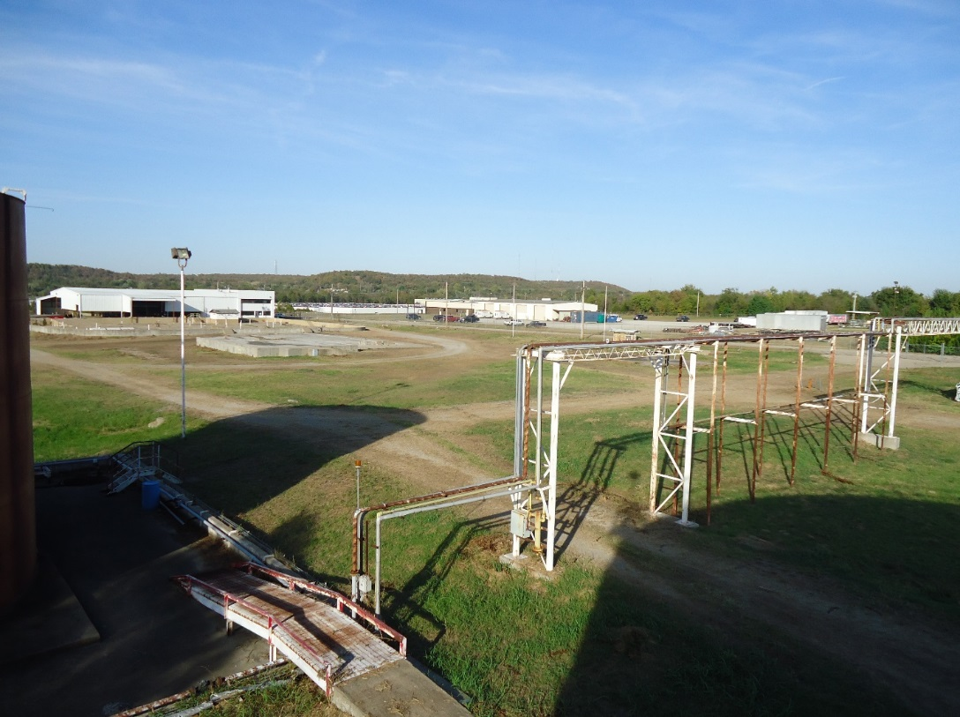
View to the Northeast from top of Tank V-69
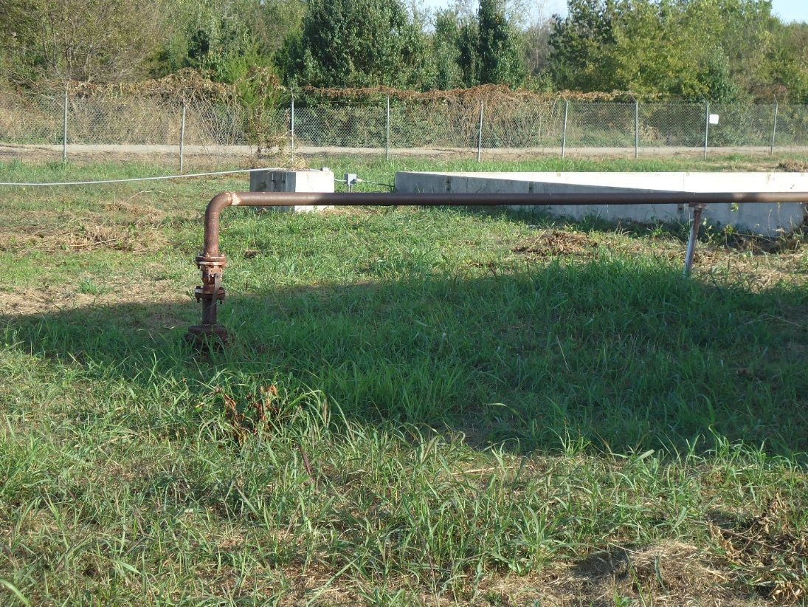
POTW discharge line entering underground sewer line

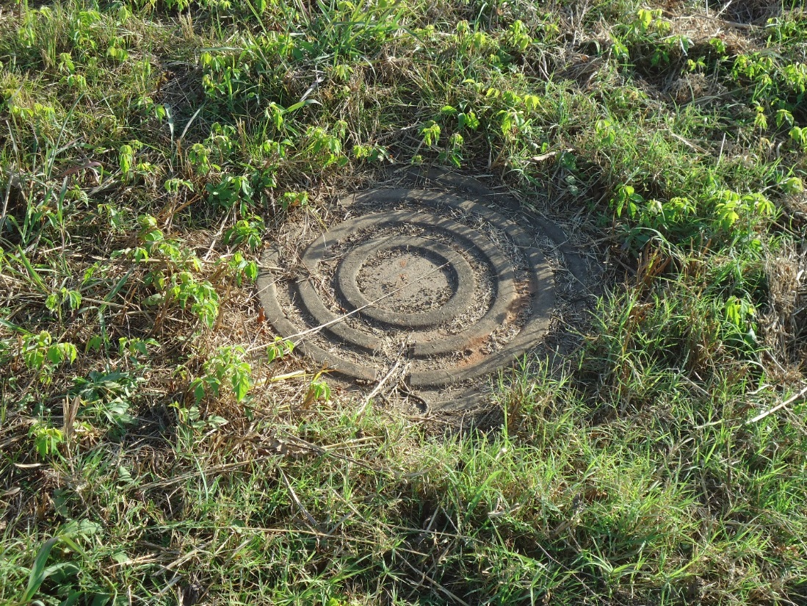
Sewer manway for sampling location for POTW discharges

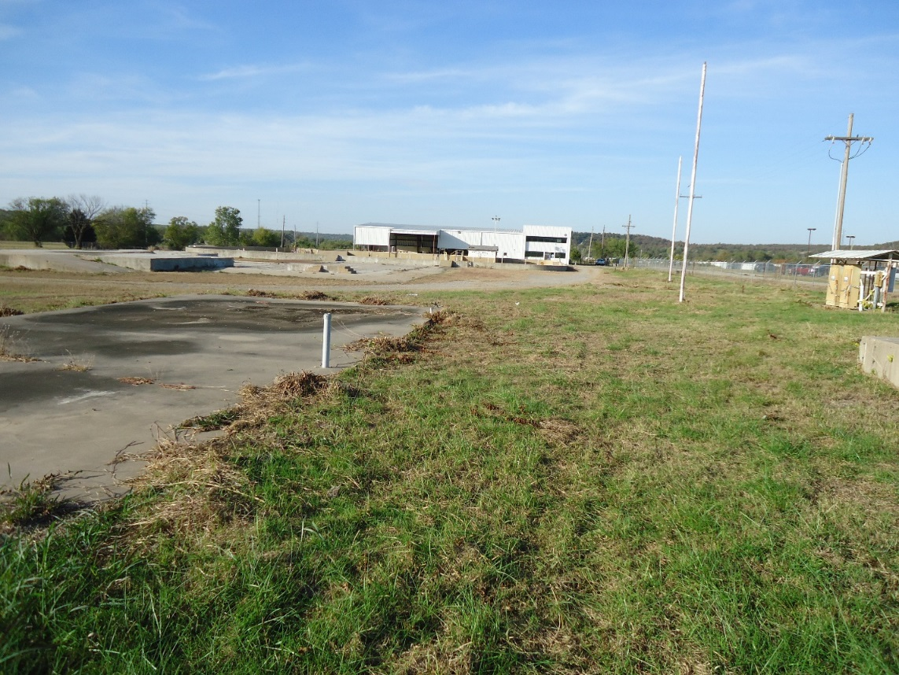

View of facility from the South facing North

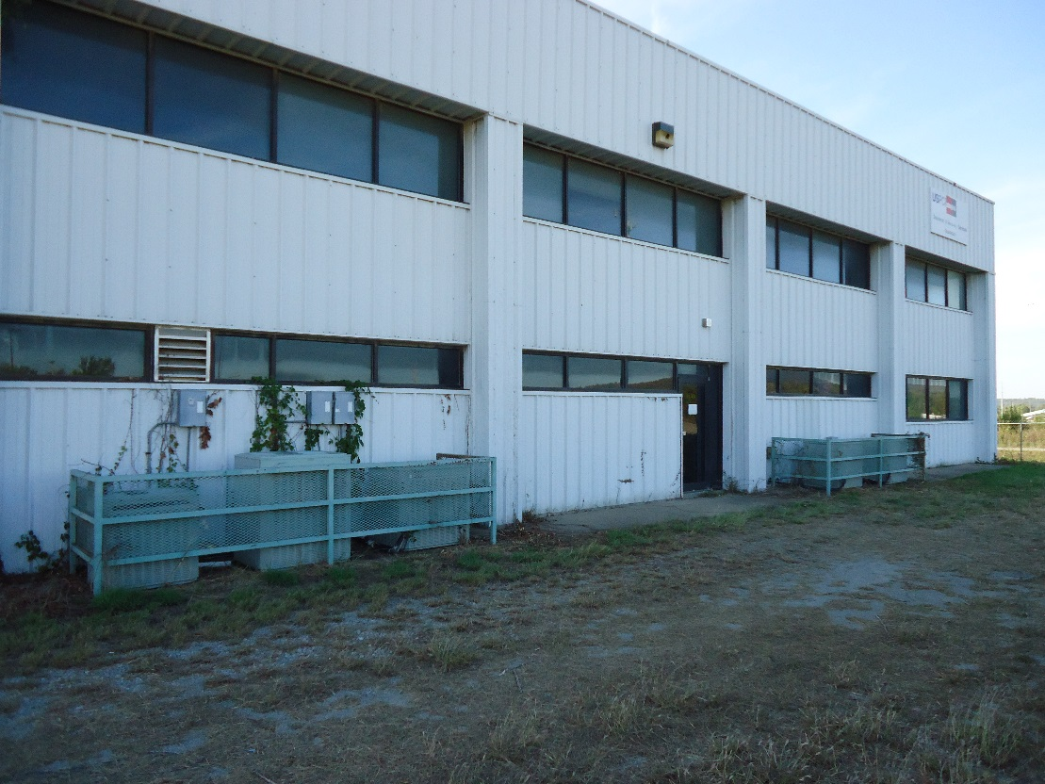
Main facility building entrance

