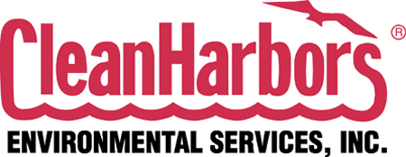

TULSA DISPOSAL, LLC
5324 West 46th Street South
Tulsa, Oklahoma 74107
EPA ID NO. OKD000632737

RCRA PERMIT RENEWAL APPLICATION

Revised October 2015

REVISIONS PREPARED BY:

CLEAN HARBORS ENVIRONMENTAL SERVICES INC.

Tulsa Disposal, LLC
5324 West 46th Street South
Tulsa, Oklahoma 74107 Revised October 2015

EPA ID NO. OKD 000632737

RCRA Permit Renewal Application

