FISCAL YEAR 2023
Oklahoma Used Tire Recycling Program
Used Tire Market Development Application for Funding Opportunities
Oklahoma Department of Environmental Quality
Scott Thompson, Executive Director
Kelly Dixon, Division Director, Land Protection Division

DEQ Website: www.deq.ok.gov

Application Deadline: March 31, 2023

TABLE OF CONTENTS

Section | Page Number
Introduction | 2
Application Process

- Eligibility Criteria | 3
- Evaluation Criteria | 4
- Description of Eligible Projects | 5
- Required Application Components | 10
- Application Submission Information | 11
- Application Review and Awarding Process | 11
- Contract Requirements for Approved Applicants | 12
Application for Funding | 13
Instructions for Application | 14
Attachment A (Budget) | 16

INTRODUCTION
Effective November 1, 2014, the Oklahoma Used Tire Recycling Act allows DEQ to use funds in the Oklahoma Used Tire Indemnity Fund (Fund) for market development projects that demonstrate the utility of the used (scrap) tires (27A O.S. 2-11-401.5). Projects will be prioritized based on greatest potential to benefit schools, communities, and local governments. A “used tire” means an unprocessed whole tire or tire part that can no longer be used for its original intended purpose but can be beneficially reused as approved by the Department [(27A O.S. §2-11-401.1(25)]. A used tire is also known as a scrap or waste tire. A tire that can be used, reused or legally modified to be reused for its original intended purpose is not a used tire.

The Oklahoma Department of Environmental Quality, Used Tire Recycling Program of the Land Protection Division (DEQ-UTP) is now accepting applications for funding for used tire market development projects from eligible entities. This packet is provided to assist applicants determine whether they meet the eligibility requirements. An application for Used Tire Market Development Funding is included in this packet.

Applications will first be screened to determine eligibility. If eligible, the projects will be ranked and prioritized based on ranking criteria. Entities with prioritized projects will be required to enter into a formal agreement with the DEQ. Once the agreement is final, prioritized projects can start the project and the entity will be reimbursed as spelled out in the formal agreement. All projects must be completed within the timeframe stipulated in the formal agreement. Funds will be reimbursed through the Fund. Reimbursement is based on available funding.

Reimbursement is available for up to $250,000. The total amount available may be awarded to one or more applicants pending available funding.

Submission of a complete application does not guarantee the applicant will receive project funding, as this process is highly competitive. Funding is awarded on a reimbursement basis and dependent on available funds.

ELIGIBILITY CRITERIA

- The applicant must submit a complete application that has been emailed or postmarked by the application deadline. A complete application is described below in the section titled “Required Application Components”.

- The applicant’s project must demonstrate new or increased uses of used tires. Example of projects can be found on page 5.

- The applicant must commit to completing the project according to the timeline specified in the contract. Work cannot begin until a purchase order has been issued and the contract has been executed. Timelines are negotiable.

- The contract with be executed between DEQ and the applicant. The applicant is responsible for all subcontracting and landowner consent associated with the project.

- The applicant must consent to DEQ oversight of the project. The applicant must report progress to the DEQ as outlined in the contract.

- The applicant must not be in litigation with the State of Oklahoma or any other public entity concerning the Oklahoma Used Tire Recycling Act, the Oklahoma Solid Waste Act, or any other DEQ Statutes. Applicant must be in compliance with any open Compliance Orders issued by the DEQ.

- The project must be located in Oklahoma.

- The project should demonstrate benefit to schools, communities, and local governments. Projects that demonstrate this benefit will be prioritized for funding.

- Applicants must attempt to source used tires or tire derived material from an Oklahoma used tire processor/recycler that is currently permitted and in substantial compliance pursuant to OAC 252:515-21-73. A list of Oklahoma processors/recyclers, also known as Qualified Applicants for Collection and Transportation (QACT), is available on the DEQ website at https://www.deq.ok.gov/wp-content/uploads/land-division/QACTListApril2016-1.pdf. Prior to issuance of a contract to fund the project, the applicant will need to submit a letter from the selected QACT stating they meet the following conditions:

  - The QACT must have the capability to process the used tires that will be purchased by the applicant.
  - The QACT has agreed to supply the necessary used tires or raw material.
  - If QACT cannot fulfill the above requirements, an external vendor can be used for acquisition of tire derived materials or product. Applicant must provide documentation from the eligible QACTs that states they cannot meet the requirements of the project or do not wish to participate.

EVALUATION CRITERIA

Evaluation of project is based on a scoring system and addresses the following six areas:

- Applicant adequately explains how the community’s needs will be met by the completion of this project (i.e., to schools, communities, or local governments) in three areas:
1.1. Project focuses on an identified need
1.2. Project will benefit the community
1.3. Project will have noticeable impact on the quality of living
- Applicant has the financial capability to complete the project. Scoring will be based on two areas:
  - Entity has design plans in place and necessary approvals for the project from City Councils, other necessary boards, etc
  - Project is an addition or extension of the applicant’s current operations or activities
  - Applicant provided a realistic budget, timeline.
  - Applicant has additional or matching funds to help fund the project to completion.
- The project must be feasible, reproducible, and market-oriented.
  - Other communities can reproduce the project and benefit in a similar way.
  - The project must help to increase end of life uses including but not limited to tire derived fuel, ground rubber products, rubberized asphalt, civil engineering, and other smaller markets including punched and stamped products, agricultural uses, etc. Scores vary depending on current market trends.
  - The project does not require additional research and development. The project can be used for demonstration purposes.
- Project’s ability to protect human health and the environment in two areas:
  - The use of recycled tires or tire derived product replaces a harmful or less sustainable material (i.e., Reduces oil-based products)
  - Project diverts more scrap tires from the waste stream than comparable projects (i.e., use of crumb rubber modified asphalt uses more scrap tires than polymer modified asphalt with similar performance grade bumps)
- Project sustainability/green development
  - The use of tire material replaces virgin material (i.e., use of used tire material replaces a virgin material; the project utilizes additional recycled or reused material)
- Project benefits State of Oklahoma not otherwise specified in the previous categories. For example, tire derived product obtained from an Oklahoma facility warrants additional points. Another example is one project that benefits multiple populations of a community (i.e., a walk-way through a park made from tire derived product serves more of the population than playground material for a school).

PROJECT EXAMPLES*

Rubberized Asphalt – Ground tire rubber can be used in asphalt paving mixes for a more durable, quieter, and more affordable paving material.

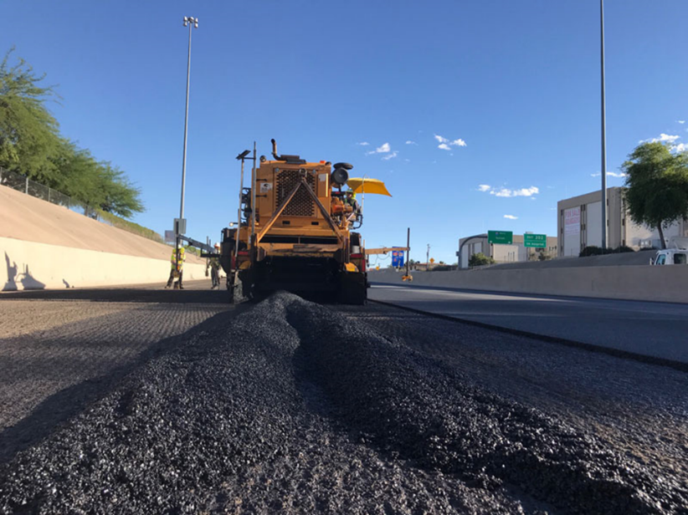
(source: www.azdot.gov/adot-blog/building-freeway-rubberized-asphalt.com)

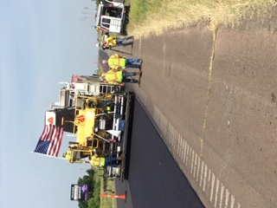
(Photo by DEQ Staff; Local road project using ground tire rubber in a dry process)

Playground Mulch – Ground tire rubber can replace traditional wood-based mulch for a longer lasting material with better fall protection.

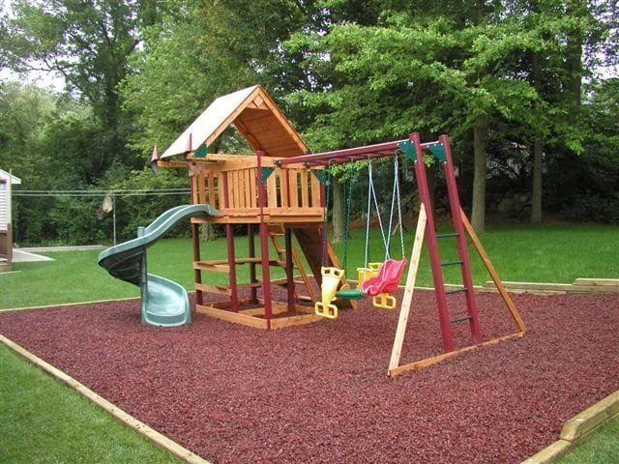
(Source: https://perfectrubbermulch.com/product/loose-fill-rubber-mulch-florida/)

Equestrian Arena Footing – Ground tire rubber can be used as a dust free, long lasting, and more protective arena base.

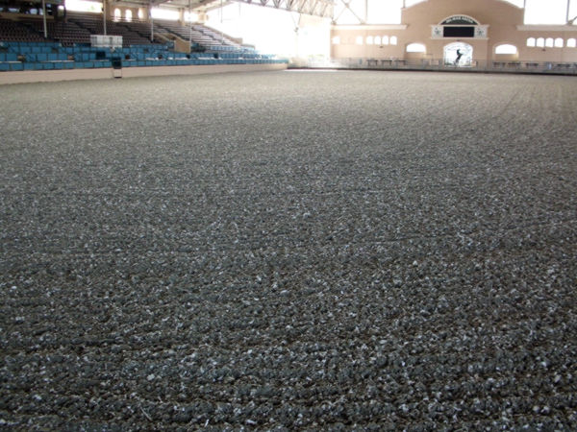(Source: https://rmpusa.com/products/equestrian-arena-footing-rubber-mulch/)

Pathways and sidewalks – Ground tire rubber can be used in pathways to provide a lower impact and non-slip alternative to traditional asphalt or concrete paths.

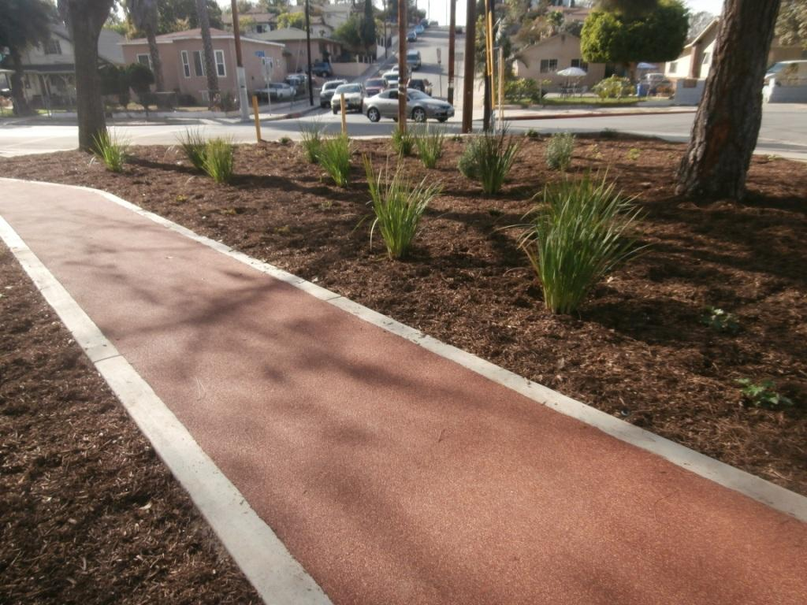
(Source: http://ladpw.org/epd/tirerecycling/demo_obregon.cfm)

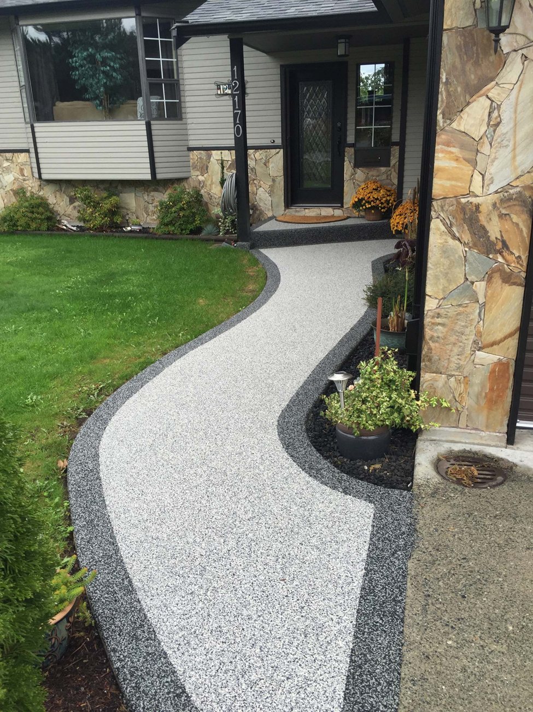
(Source: https://ecopaving.com/walkway-paving/)

Athletic Turf infill – Ground tire rubber can be used in artificial turf to help provide traction and cushioning

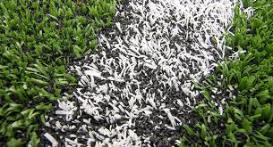
(Source: https://www.smithers.com/resources)

*Other projects may be eligible. The examples provided is not an exhaustive list. CalRecyle has an extensive list of products made from recycled rubber. Go to https://www.e-productcatalog.com/TDPCatalog/328/ for more ideas. DEQ does not endorse specific products or vendors.

REQUIRED APPLICATION COMPONENTS

A separate application must be submitted for each proposed market development project. All information submitted in the application must be current.

FULL APPLICATION:

Application must include all of the components listed below to be considered complete. Incomplete responses may result in a determination that the application is not eligible for funding:

- Application
- Project Narrative (Narrative should include a description of how the project meets the evaluation criteria)
- Project Budget
- Applicable Supplemental Documentation (supplier agreement or letter; letter of interest from end user; approval from relevant Boards, Councils, etc.)

Full applications are due March 31, 2023

APPLICATION SUBMISSION INFORMATION

The DEQ must receive completed applications emailed or postmarked no later than March 31, 2023. Proposals received after this deadline will not be evaluated.

All questions regarding application preparation and submission should be directed to Kole Kennedy at 405-702-5177 or email Kole.Kennedy@deq.ok.gov.

The application must be mailed or delivered to:

Oklahoma Department of Environmental Quality
Used Tire Recycling Program
Land Protection Division
P.O. Box 1677
Oklahoma City, OK 73101

APPLICATION REVIEW AND AWARDING PROCESS

Application for funding will be reviewed and scored individually by five Land Protection Division staff members who are collectively referred to as the Review Team (RT). Project evaluation will be based on the evaluation criteria outlined on page 4. The review team will meet to finalize scores using consensus. The RT will prioritize projects based on available funding. Selected applicants will be notified and invited to enter into a contract with DEQ. Awards are provided as reimbursement. Evaluation information concerning an application will be available upon request. Unsuccessful applicants may reapply in future cycles, dependent on available funding. The DEQ will not award funding or pay any costs incurred by the applicant in the preparation and submission of their application.

Contract Requirements for Approved Applicants

Once selected, applicants will be required to enter into a standard DEQ contract. The original application will become part of the contract. No reimbursement can be provided until a contract is executed by both applicant and DEQ and purchase order is issued. DEQ will provide a formal notice to proceed. The contract will stipulate a project period during which the project must be completed to the satisfaction of DEQ. Partial reimbursements may be requested upon documentation of work completed and eligible expenditures. Please note the money received is in the form of a reimbursement. Time extensions may be granted upon receipt of documentation as required by the Program.

OKLAHOMA USED TIRE RECYCLING PROGRAM – MARKET DEVELOPMENT GRANT APPLICATION FOR FISCAL YEAR 2023/2024

For additional information, contact DEQ Used Tire Recycling Program at 405-702-5100

1. Applicant Name:
2. Street Address:
3. Project Location (if different from above):
4. Telephone Number:
5. Contact Person:
6. Email:
7. Project Description Summary (attach):
8. Amount of Funding Requested:
9. Total Project Cost:
10: Estimated Amount of Tires to be Used (check one):
Passenger Tire Equivalents (PTE’s) __________________
Tons ________________

11. Line Item Budget (attach):
12. Relevant Supplemental Documentation:
Applicant Signatory

I certify that the information contained on this form, to the best of my knowledge and belief, is true, accurate, and complete. I am aware that submitting false information may result in ineligibility or forfeiture of any reimbursement.

Print Name __________________________________________

Sign Name___________________________________________ Date ____________________

APPLICATION INSTRUCTIONS

1. List the applicant’s name.

2. Applicant’s mailing address.

3. Project location, if different than applicant’s mailing address.

4. Primary telephone number for contacting applicant.

5. Contact person for the project, if different from applicant’s name

6. Primary email address for contacting applicant.

7. Attach a detailed description of the project that identifies the project goals and what the project will accomplish. Refer to the evaluation criteria on page 4. This description should include, but is not limited to the following:

- A complete description of the entire operations related to implementing the project, not limited to the part of the project receiving reimbursement (i.e., only one mile of walkway will be used to demonstrate the use of recycled tire product but the entire project is 3 miles).
- If the project is an expansion or addition to a current operation or activity, include a description of the current operations/activities and how the proposed project will fit into current operations/activities (Criterion 2.2).
- Provide detailed sketch or diagram of project location, if applicable, or project process, if applicable.
- Provide documentation that demonstrates compliance with applicable federal, state, and local laws, rules, ordinances, and regulations and obtain all applicable permits and licenses (Criterion 2.1).
- Provide a realistic budget, timeline, and additional or matching funds reflecting ability to fund the project to completion (Criteria 2.3 and 2.4).
- Describe the process to be used for measuring the progress and success of the project. Include specific types of data collection or project measurement methods. Successful applicants will be required to submit these measures in quarterly and/or final reports.
- Provide a detailed narrative that explains how the project focuses on an identified need, will benefit to schools, community, and local governments, and have a noticeable impact on quality of living (Criteria 1.1, 1.2, and 1.3).
- Discuss the potential for this project to be replicated by other similar entities and serve as a model to those entities. Identify groups that could implement a similar project with similar results (Criterion 3.1).
- Describe how the project implements a higher end use application (Criterion 3.2)
- Describe any relevant research on the use of the product and if the project will be used for demonstration purposes (Criterion 3.3). Include partners in the collaboration process.
- Describe how the use of recycled tires or tire derived product replaces harmful or less sustainable materials and how the project diverts scrap tires from the waste stream (Criteria 4.1. and 4.2).
- Describe how the project replaces the use of virgin material with tire derived product (Criterion 5.1).

8. List the amount of funding requested for the project. Funding is available for a total of $250,000 that may include one or multiple recipients. You will outline a detailed budget in Paragraph 11 below.

9. Please list the total cost of the project, if it is more than what is requested for reimbursement.

10. Estimate the amount of used (scrap) tries to be used for this project. You can report this amount either in tonnage, or by Passenger Tire Equivalents (PTE’s).

1 PTE=22.5 lbs.
car tires=1 PTE’s
truck tires=5 PTE’s
oversize (ag, heavy equip.) tires=15 PTE’s

11. Attach a line-item budget for the project. See page attachment A on page 16 for an example.

12. Submitting supplemental documentation that demonstrates the project’s alignment with the evaluation criteria (page 4) will strengthen the application. Examples are letter of interest from a customer, supplier agreement with a QACT, approval from relevant boards, councils, or committees regarding the implementation and/or construction of the project.

ATTACHMENT A: PROJECT BUDGET CHART

Line-Item Number | Quantity | Budget Line Item/ Description of Item | Unit Pricee | Budget  Line-Item Amount | DEQ Use Only

