AGENDA
DEPARTMENT OF ENVIRONMENTAL QUALITY
SOLID WASTE MANAGEMENT ADVISORY COUNCIL

A PUBLIC MEETING

January 12, 2023, at 10:00 AM
Oklahoma Department of Environmental Quality
707 N. Robinson
1st Floor, Multi-Purpose Room
Oklahoma City, Oklahoma

To conserve resources, no hard copies of public documents associated with this council agenda, were copied for distribution at this meeting. Documents, including copies of proposed rules, are accessible electronically by following the QR code below.

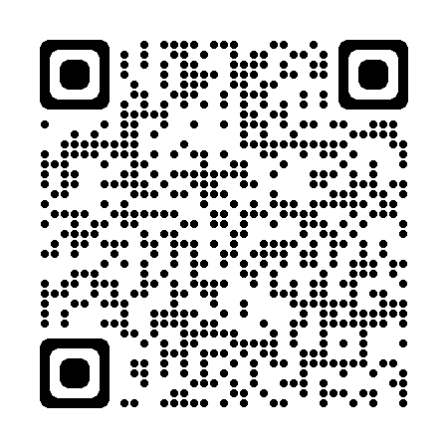
1. Call to Order – Jim Linn, Chairman

2. Roll Call – Quiana Fields

3. Approval of the Minutes for the September 8, 2022, Solid Waste Management Advisory Council Meeting. Roll Call Vote by the Council.

4. Director’s Report – DEQ

5. Keep Oklahoma Beautiful Award State Partner Award Presentation

Jeanette Nance, Executive Director of Keep Oklahoma Beautiful, will present the Keep America Beautiful State Partnership Award to DEQ for collaborating on the Oklahoma Clean Communities Program.

6. Public Rulemaking Hearing

Discussion of proposed changes to Chapter 515 Management of Solid Waste. The Department of Environmental Quality is proposing to revise OAC 252:515-23-3. Disposal of untreated, regulated medical waste, to make clear that regulated medical waste generators, including small quantity generators, are also subject to any additional provisions that may be required by the Oklahoma State Department of Health.

I. Introduction – Patrick Riley, DEQ
II. Questions and discussion by Council
III. Questions and discussion by Public
IV. Discussion and possible action by Council
V. Roll call vote

7. PFAS Work Group Summary Report

Discussion of potential changes to Chapter 515 Management of Solid Waste to include new regulations specific to the disposal of certain types of per- and polyfluoroalkyl substances (PFAS) was held at an informal workgroup meeting November 8, 2022. A verbal report will be provided summarizing the discussion.

I. Introduction – DEQ
II. Summary of work group meeting-Kaylee Shiplet, DEQ and Council participants
III. Questions and discussion by Council
IV. Questions and discussion by Public
V. Possible Action by Council

8. Land Protection Division Environmental Justice (EJ) Policy.

Information will be shared about Land Protection’s Environmental Justice Policy and how it is used during the solid waste permitting process.

I. Introduction – DEQ
II. Questions and discussion by Council
III. Questions and discussion by Public

9. Public Forum – Open Discussion

10. New Business

Limited to any matter not known or which could not have been reasonably foreseen prior to the time of posting the Agenda (24 hours prior to the meeting).

11. Adjournment

If you have a disability and need an accommodation, please notify the DEQ three days in advance at (405) 702-5213. For hearing impaired, the TDD Relay Number is 1-800-722-0353. Current and proposed rules are available at the Land Protection Division office located at 707 N. Robinson, Oklahoma City, and available through the DEQ website at: www.deq.ok.gov.

