DEQ Environmental Education Grant Guidelines

The Oklahoma Department of Environmental Quality (DEQ) seeks to encourage teachers and youth leaders to develop effective environmental education programs, environmental projects and/or strategies by offering yearly environmental education grants.

Grant Requirements
Applicants must be an Oklahoma teacher, public or private (preschool-12th grade), school environmental club, youth group leader, and/or organization with a youth component to apply for the grant.
The proposed project must:
- have an environmental education focus
- include direct student involvement
- contain clear ties to classroom learning objectives or state curriculum standards
- be completed by the end of the next school year.
Additional suggestions:
- community collaboration is strongly encouraged
Frequently Asked Questions
- When are grant applications due?
All applications are due by March 11, 2022
- What amount of funding can we request?
This year, the maximum amount you can apply for is $1,000 and the minimum is $100.
- Do I have to be a school to apply for the grant?
Any organization, community group, nature center, museum, school, etc. that is based in Oklahoma and that involves youth in environmental and/or conservation education is welcome to apply for this grant.
- When will funds be awarded?
If your application is successful, you can expect to receive a check in April.
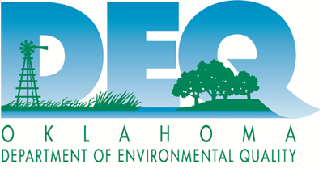

Updated 02/2022

