**DEQ Environmental Education Grant Guidelines**

The Oklahoma Department of Environmental Quality (DEQ) seeks to encourage teachers and youth leaders to develop effective environmental education programs, environmental projects and/or strategies by offering yearly environmental education grants.

**Grant Requirements**

Applicants must be an Oklahoma teacher, public or private (preschool-12th grade), school environmental club, youth group leader, and/or organization with a youth component to apply for the grant.

 The proposed project must:

* have an environmental education focus
* include direct student involvement
* contain clear ties to classroom learning objectives or state curriculum standards
* be completed by the end of the next school year.

Additional suggestions:

* community collaboration is strongly encouraged

**Frequently Asked Questions**

* **When are grant applications due?**  
  All applications are due by December 1, 2022
* **What amount of funding can we request?**  
  This year, the maximum amount you can apply for is $1,000 and the minimum is $100.
* **Do I have to be a school to apply for the grant?**  
  Any organization, community group, nature center, museum, school, etc. that is based in Oklahoma and that involves youth in environmental and/or conservation education is welcome to apply for this grant.
* **When will funds be awarded?**  
  If your application is successful, you can expect to receive a check in April.

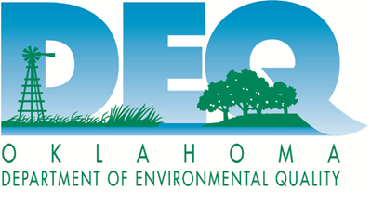

Updated 10/2022